Contestability in sources
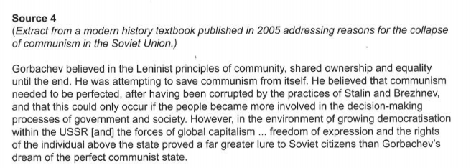
- What is the contestable issue in this source?
______________________________________________________________________________________________________________________________________
Why is it contestable?
- Who wrote the source? _________________________________________
- What do you need to know about this person’s point of view towards the issue/event in the source?
______________________________________________________________________________________________________________________________________
- What other viewpoints about this issue exist?
_________________________________________________________________________________________________________________________________________________________________________________________________________
- What period of time was the source written? What was happening at this time?
___________________________________________________________________
- How might this effect the source?
__________________________________________________________________________________________________________________________________________________________________________________________________________________________________________________________________________________________________________________________________________________________________________________________________________________

